Topic 5: PRINCIPLES AND PRACTICES OF DOUBLE ENTRY
Learning Objective:
By the end of the lesson, students should be able to:
- State the double entry principle and list its procedures
- Differentiate between cash and credit transactions.
- Identify and apply the double entry principle in posting business transactions.

- DOUBLE ENTRY BOOK KEEPING
The principle states that for every debit entry, there must be a corresponding credit entry and vice versa. It is the foundation of book keeping and it operates on the basis that every financial transaction must have two aspects:
Debit: Receiver (receiving account)
Credit: Giver (giving account)
The procedures are:
- The keeping of books of account.
- The division of each book into separate accounts.
- Each account is divided into 2 halves, left side; Debit (Dr) and right side; Credit (Cr).
- All transactions must be recorded in two accounts, one debited and the other credited.
- The giving account is credited and the receiving account is debited with the value of the transaction.

- CASH AND CREDIT TRANSACTIONS
Financial transactions are classified into cash and credit transactions:
- Cash transactions: the buyers pay immediately for goods bought and no account will be opened in respect of a supplier / customer. Steps in recording cash transactions:
- Prepare two accounts.
- Identify the “Giving Account” and the “Receiving Account”
- Then apply the principle – Cr (giver), Dr (receiver)
NB: All cash transactions must pass through the cash book.
- Credit transactions: these are transactions in which transfer of ownership takes place before payment to supplier i.e. settlement is deferred to a future date. Steps in recording credit transactions:
- Prepare day books: sales, purchases, returns and journal paper
- Prepare two accounts
- Identify the “Giving Accounts” and the “Receiving Accounts”
- Apply the principle of double entry.

GRAPHICAL REPRESENTATION
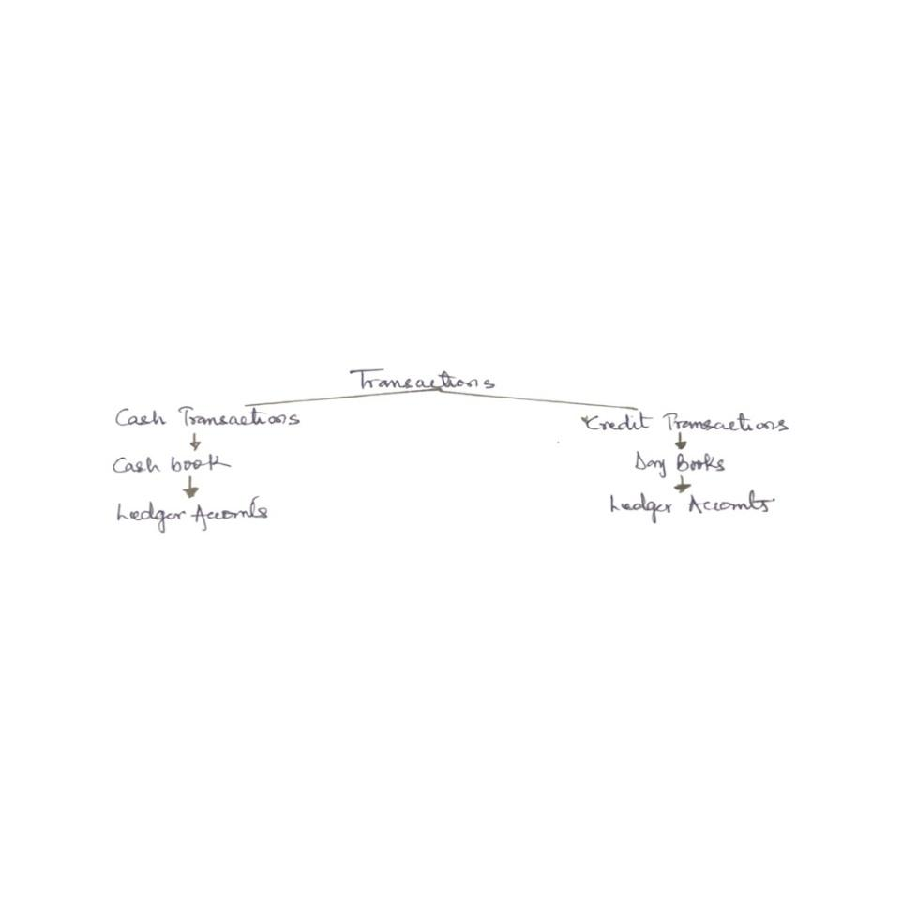
NOTE:
DEBIT ENTRY REPRESENTS | CREDIT ENTRY REPRESENTS
- An increase in the value of assets | A decrease in the value of assets
- A decrease in the liability account | An increase in liability value
- An item of expenditure or expenses | An item of income or gain

- ILLUSTRATION
Apply double entry principle to the following transactions
Jan 1: Mr Ojo started business with ₦40,000 cash
Jan 2: paid ₦4,500 cash for rent
Jan 5: Bought motor vehicle ₦600 paying by cheque
Jan 8: Withdrew cheque for private use ₦1,500
Jan 15: Purchase goods ₦1,000 on credit from Okolo
Jan 19: Goods worth ₦30,000 were returned to supplier Ojo

APPLICATION
 | EFFECT | ACTION REQUIRED
Jan 1 | Increase in capital: Capital account.  Increase in asset: Cash account | Cr: Capital Account (giver)  Dr: Cash Account (receiver)
Jan 2 | Increase in Exp: Rent Account  Decrease in Asset: cash account | Dr: Rent Account (receiver)  Cr: Cash Account (giver)
Jan 5 | Increase in Asset: Motor vehicle account  Decrease in Asset: Bank account | Dr: Motor vehicle (receiver)  Cr: Bank Account (Giver)
Jan 8 | Increase in Drawings: Drawings Account  Decrease in Asset: Bank Account | Dr: Drawing Account (receiver)  Cr: Bank Account (giver)
Jan 15 | Increase in Liability: Okolo Account  Increase in purchases: Purchase Account | Dr: Purchase Account (receiver)  Cr: Okolo Account (giver)
Jan 19 | Decrease in Liability: Ojo Account  Decrease in Return / outwards Account | Dr: Ojo Account (receiver)  Cr: Return Outward Account (giver)

DRILL
- State and explain the double entry principle
- Enumerate the procedures to be followed in preparation of account
- Show which account is to be debited and credited for the following
- Started business with cash
- Took cash and paid into bank
- Land sold for cash
- Goods sold to Ayodeji on credit
- Enter the following transactions in the necessary account
Dec 2: Paid insurance by cheque
Dec 3: Received refund of rent ₦500,000 cash
Dec 5: Took ₦500 from cash will and paid into the bank
Dec 9: Withdrawn goods ₦300 for use
- Select the most appropriate option:
- Debit, payments ; Credit, Receipts
- Debit, Receipts; Credit, Payments
- Debit; Receiver ; Credit, giver
- Debit; giver ; Credit; Receiver

